Year 12 Summer Pre-Start Task: Britain 1900 - 1951
Welcome to A-Level History! To set us up for success, you have a task to complete for me over the holidays. This task is essential in giving you a foundation of knowledge that you will need in order to access/understand a large proportion of our content. This is not expected to be a mammoth task for you, as I know you have tasks for the Germany topic, and from other subjects. This being said, A-Level is the bridge between school and university, and requires commitment and application of effort, so I do expect for this to be completed at a high standard.

Your task is to create a political spectrum (like a timeline) detailing where each of the political ideologies and parties belongs. I have put an example that is based around Germany in 1919 at the bottom of these instructions to give you a general idea of what I am talking about. You may present this however you like, either hand written, or produced digitally. As I am sure you’re aware, you will be completing classwork on a laptop, so I suggest that if you do this by hand, you scan it into your laptop so it can be with the rest of your work.
You need to place each of the features below onto your political spectrum, with an explanation of what each means/involves, what the parties stand for, and the relationship between the parties. The definitions you create need to be in your own words, so that it makes sense if you come back to it at a later date. These can be written on your spectrum or alongside it…it us up to you!

The features that need to be on your spectrum are:
Left-Wing
Right-Wing
Communism
Capitalism
Socialism
Liberalism
The main political parties in Britain from 1900 – Conservative, Labour, Liberal.
Other modern political parties in the UK – add these on but do not worry about adding explanations, these are for context so you can see where our main parties fit into the grand scheme of things.

There is a wealth of information that you can find on the internet and in books, magazines, or the news.
You are expected to carry out your own research for this, although I have put some links to resources below to get you going.
Communism and socialism
https://www.youtube.com/watch?v=FrtDZ-LOXFw
Capitalism, socialism and communism
https://www.youtube.com/watch?v=53vmQNVBm0w
A brief run-down of the political parties
https://about-britain.com/institutions/political-parties.htm
Liberalism and the liberal party
https://www.britannica.com/topic/Liberal-Party-political-party-United-Kingdom
Labour Party
https://www.britannica.com/topic/Labour-Party-political-party
Conservative Party
https://www.britannica.com/topic/Conservative-Party-political-party-United-Kingdom
Example using Germany in 1919 (although don’t forget that you need explanations about each feature!)
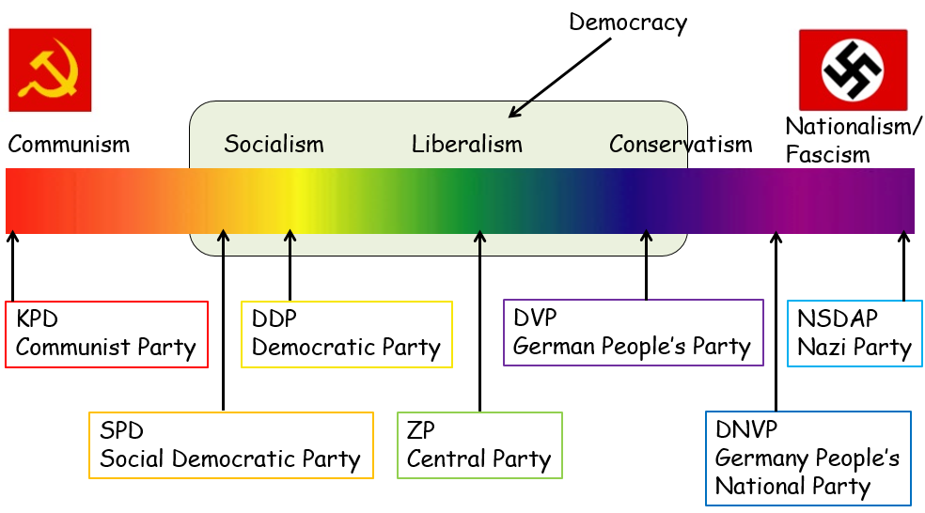

I look forward to meeting you all in September, and in the meantime I hope you enjoy your extended Summer!

Miss Lapworth

