Bienvenue!
Congratulations on selecting French A Level. You have opened the door of opportunity! Studying French will enrich your life, giving you opportunities to travel abroad and to learn about different cultures and different ways of life. Studying a language will also enhance your life chances, as universities and employers tend to prefer candidates who can speak more than one language.
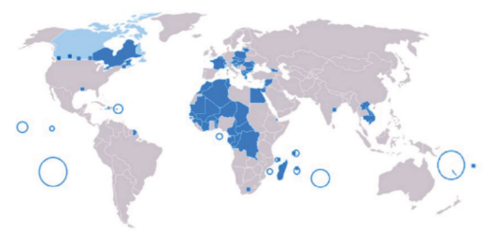
Did you know that linguists are better communicators and writers and have a better understanding of their own language too? Students who study languages do better in tests and learning a language will improve the functionality of your brain and improve your memory skills.
French is currently spoken by approximately 300 million people in a huge range of countries. Knowing French means you could communicate with a huge number of speakers around the world!
Studying A Level French will enable you to learn the French language and you will also gain an in-depth insight into the cultural, social, political, and artistic aspects of the French speaking country/countries you will study.

Introduction to the course …
Type of course: 2 year, linear (final exams in Yr 13) course with internal AS style exams/mocks in the spring/summer of Year 12.

Link to specification: http://aqa.org.uk/subjects/languages/as-and-a-level/french-7652/

Content of exams:
- Paper 1 - Listening, Reading and Writing + Translation (F to E and E to F)
  - based on all topics studied in Years 12 and 13
  - 2hrs 30 mins, 100 marks, worth 50% of A-Level
- Paper 2 - Essay paper – written in French
  - 2 x essays: 1 x book and 1 x film (approx. 300 words each)
  - 2 hours, 80 marks, 20% of A-Level
  - Film to be studied (start Autumn Yr 12) ‘Entre les Murs’- Watch this clip https://www.youtube.com/watch?v=QPXyGosb3_g
  - Book to be studied (start at end of Yr 12) ‘No et Moi’ par Delphine de Vigan
- Paper 3 – Speaking
  - Detailed discussion of one topic card from all topics studied in Yrs 12 and 13
  - Presentation and discussion on Individual Research Project (IRP)
  - Max 16-18 mins, 60 marks, 30% of A-Level

Year 12 topic content:
- La famille
- La cyber-société
- Le rôle du bénévolat
- La patrimoine
- La musique francophone contemporaine
- Le septième art

Year 13 topic content:
- Les ados, le droit de vote et l'engagement politique
- Manifestations, grèves – à qui le pouvoir ?
- La politique et l'immigration
- Les aspects positifs d'une société diverse
- Quelle vie pour les marginalisés ?
- Comment on traite les criminels

You will need:

- A5 journal/notebook for vocabulary
- A4 lever arch file (big and tall)
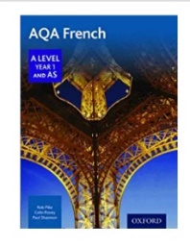
- A4 loose leaf paper
- Set of at least 10 dividers

- Textbook To be loaned from school (You can buy your own copy if you wish):
AQA French A Level Year 1 and AS, Pike, Povey, Shannon, Oxford, 2016
ISBN 978 019 836688 1
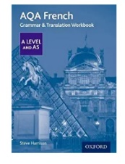
- Grammar workbook School will provide:
AQA French Grammar and Translation Workbook A Level and AS, Harrison, Oxford, 2017 ISBN 978 019 841553 4

Summer Preparation Tasks X 3 - To do before term starts:

Tâche 1 Grammar – ***required learning***:

Revise and be confident with the following grammar points:

- Present tense regular and irregular -er, -re and -ir verbs
- Past tense / passé composé (and when to use avoir/être and how any endings change with être)
- Reflexive verbs and use of être in past tense
- Imperfect tense (j’étais)
- Future tense with aller (je vais manger) and future tense with avoir endings (je mangerai)
- Conditional tense
- Adjective endings and when they are used

You should review your GCSE notes and exercises but the following will also be helpful:
- www.languagesonline.org.uk (scroll down to the more advanced/GCSE exercises)
- BBC Bitesize French https://www.bbc.co.uk/bitesize/subjects/z9dqxnb

Complete the following grammar activities to revise you can/should use an online verb conjugator or a verb conjugator book to complete these.

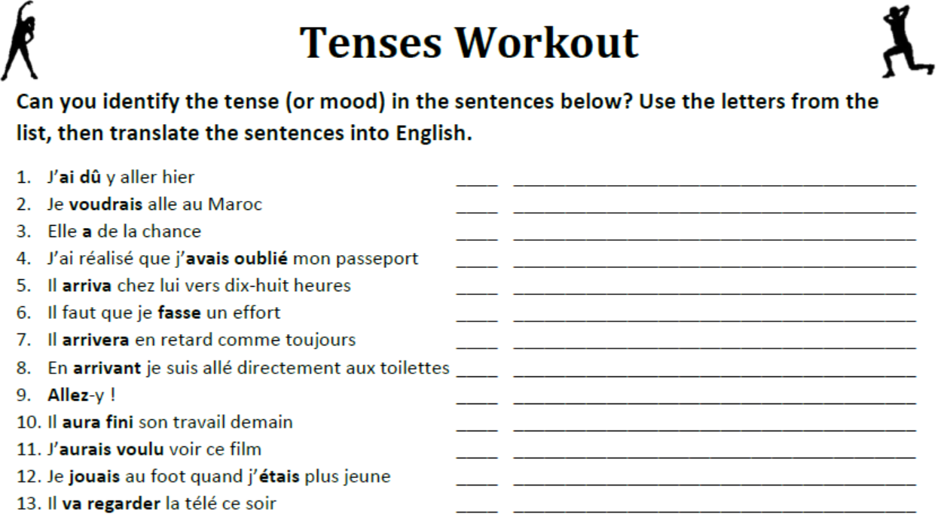

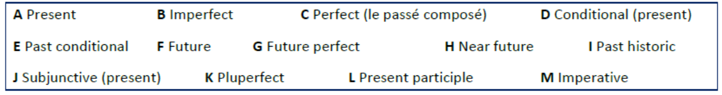

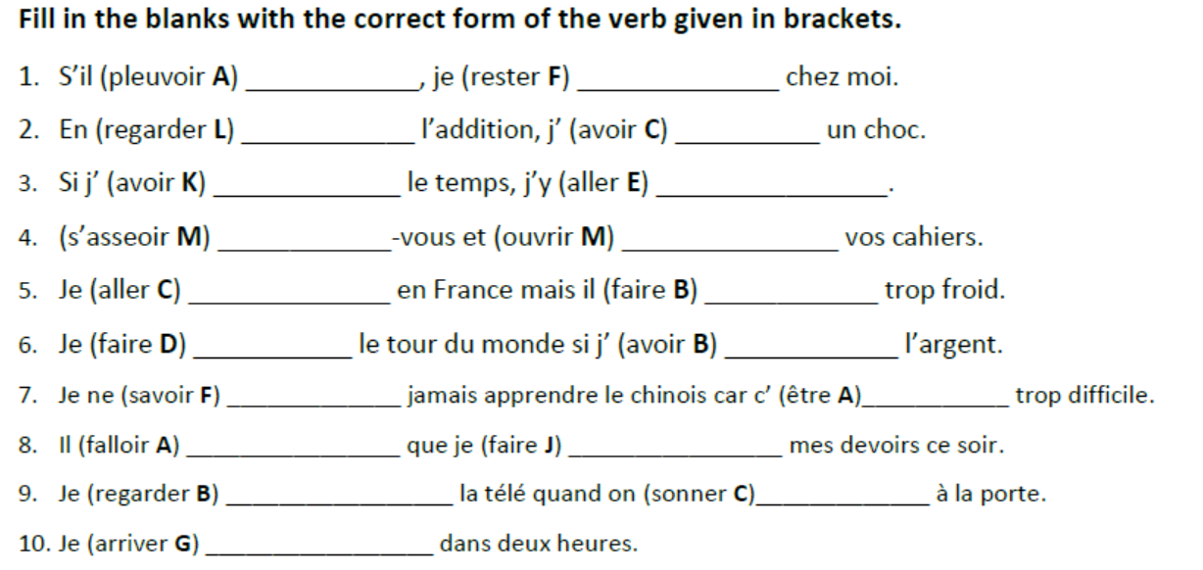
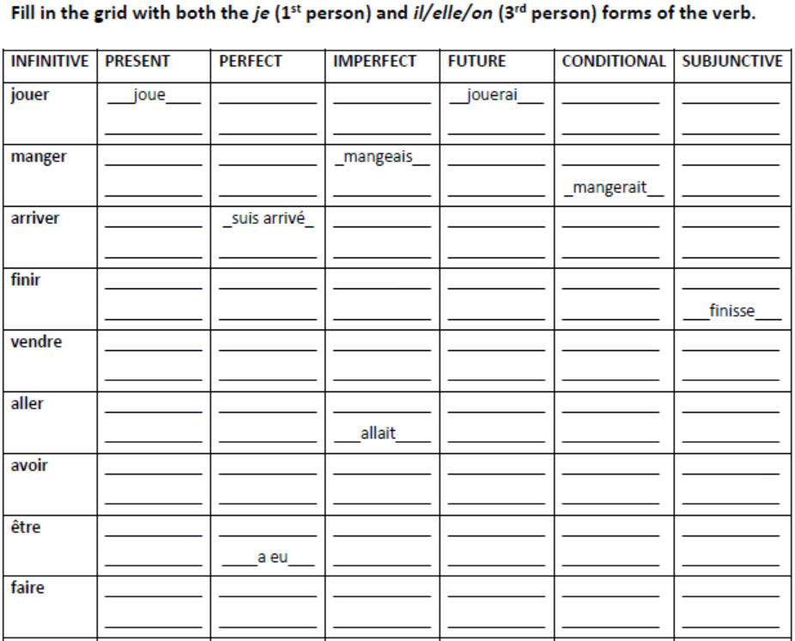

Tâche 2 Familiarisation of topic vocabulary, phrases, expressions ***required learning***

Do some work familiarising yourself with the vocabulary you will be using at A level.
- Quizlet https://quizlet.com/415718988/aqa-a-level-french-flash-cards/
- Memrise https://app.memrise.com/course/98647/french-a-level-vocab/

Familiarise yourself with the topics you are going to study next year and year 2 of A Level. Translate the sub-themes below into English, use a dictionary or online dictionary to help.

Year 1_Aspects of French-speaking society: current trends

French | English Translation
1 La famille en voie de changement | The changing family
• La vie de couple: nouvelles tendances
• Monoparentalité, homoparentalité, familles recomposées
• Grands-parents, parents et enfants: soucis et problèmes
2 La “cyber-société | • Cyber - society
• Comment la technologie facilite la vie quotidienne
• Quels dangers la cyber-société pose t-elle?
• Qui sont les cybernautes?
3 Le rôle du bénévolat | • The role of volunteers
• Qui sont et que font les bénévoles?
• Le bénévolat: quelle valeur pour ceux qui sont aidés?
• Le bénévolat: quelle valeur pour ceux qui sont aident?
Artistic culture in the French-speaking world

French | English Translation
4 Une culture fière de son patrimoine | • A culture proud of its inheritance
• Le patrimoine sur le plan national, regional et local
• Le patrimoine et le tourisme
• Comment le patrimoine reflète la culture
5 La musique francophone contemporaine | • Contemporary French music
• La diversité de la musique francophone contemporaine
• Qui écoute et apprécie la musique francophone contemporaine?
• Comment sauvegarder la musique francophone contemporaine?
6 Le septième art | • The 7th art – French cinema
• Pourquoi le septième art?
• Evolution du cinéma: Les grandes lignes
• Le cinéma: une passion nationale
Year 2_Aspects of French-speaking society: current issues

French | English Translation
1 Les aspects positifs d’une société diverse | • Positive aspects of a diverse society
• L’enrichissement dû à la mixté ethnique

• Diversité tolérance et respect
• Diversité – un apprentissage pour la vie
2 Quelle vie pour les marginalisés? | • Life for the socially marginalised
• Qui sont les marginalisés?
• Quelle aide pour les marginalisés?
• Quelles attitudes envers les marginalisés?
3 Comment on traite les criminels | • How criminals are treated
• Quelles attitudes envers la criminalité?
• La prison – échec ou succès?
• D’autres sanctions

Aspects of political life in the French-speaking world

French | English Translation
4 Les ados, Le droit de vote et l’engagement politique | • Youth, the right to vote and political engagement
• Pour ou contre le droit de vote?

• Les ados et l’engagement politique, motivés ou démotivés?
• Quel avenir pour la politique?
5 Manifestations, grèves – a qui le pouvoir | • Demonstrations and strikes - who has power
• Le pouvoir de syndicats
• Manifestations et grèves – sont-elles eficaces?
• Attitudes différentes envers ces tensions politique
6 La politique et l’immigration | • Politics and immigration
• Solutions politiques à la question de l’immigration
• L’immigration et les partis politique
• L’engagement politique chez les immigrés

Tâche 3 Write a film analysis. ***required learning***

The film is “l’Ascension” by Ludovic Bernard staring Ahmed Sylla. Work through the following to complete this task:

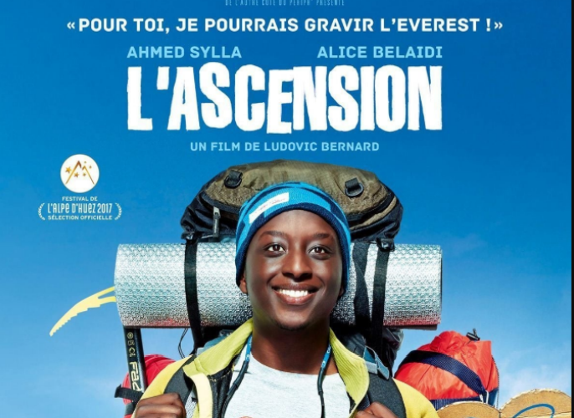

Watch the Trailer : https://www.youtube.com/watch?v=go9zvQcq5Jo

Watch the whole film:
L’Ascension (Title in English = The Climb) – film by Bernard Sylla (Age rating 15. This film is currently available on Netflix + you can add English subtitles)

Look up the French for the following vocabulary relevant for this film.

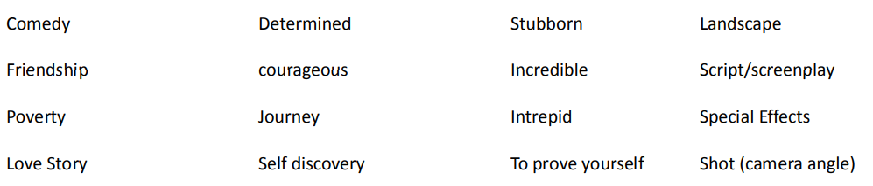

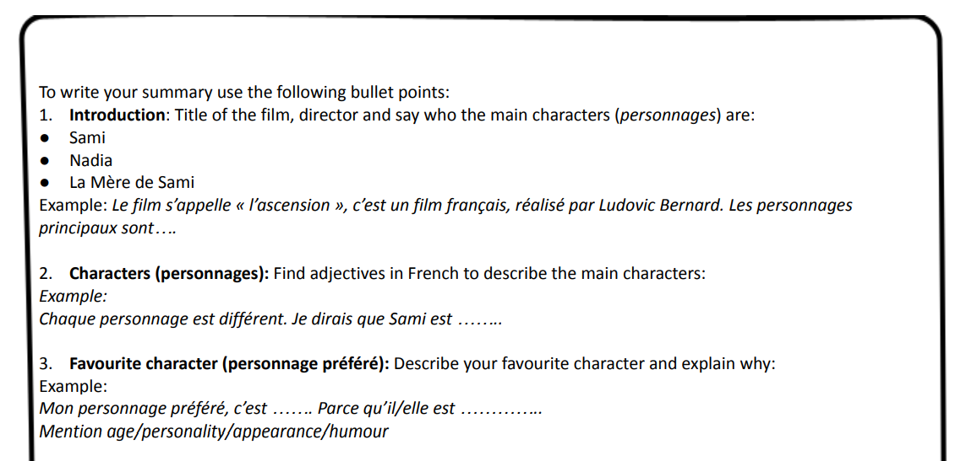
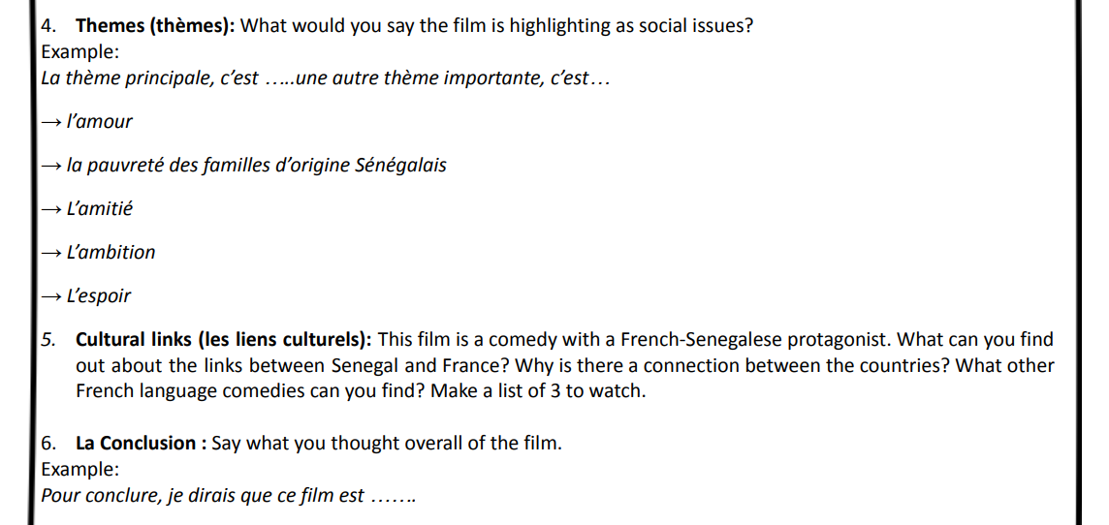

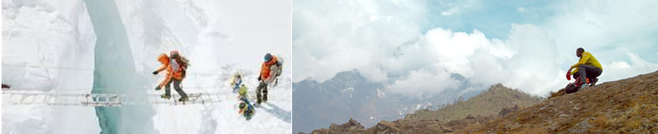

Students Choice of further Independent Learning: Choose a selection of activities from each of the following categories

1 Films/Series to watch online
- Ultimate list of French films on Netflix: https://frenchflicks.com/read-49/items/watch-french-films-on-netflix-2019.html
- Ultimate list of French films on Amazon Prime https://frenchflicks.com/read/items/the-best-french-films-on-amazon-prime.html
- Watch ‘Entre les Murs’ in preparation for studying this film in September
- 100 Best French movies of all time https://www.timeout.com/paris/en/film/best-french-movies
- Les Intouchables
- Le Fabuleux Destin de Amélie Poulain / Amélie
- Bienvenue Chez Les Ch’tis
- La Vie en Rose
- La Haine
- There are also some great French series out there to binge on, we particularly recommend ‘Dix Pour Cent’(Call My Agent) and ‘L’Agence’ on Netflix and there are some great ones on 4OD from the Walter Presents section.

2 Music, Books and Podcasts
- Discover French music on Spotify: https://open.spotify.com/search/musique%20francaise
- Find a French song/band/artist you like and complete the gapfills until you can complete ‘advanced’ (or even ‘expert’?!) https://lyricstraining.com/fr/
- Research Stromae excellent singer and currently touring https://www.youtube.com/watch?v=oiKj0Z_Xnjc
- Find some French language podcasts that you enjoy and listen to them regularly
- Read the book you will be studying in Year 2 of your A level ‘No et Moi’
- Discover the Asterix and Tintin series

3 News and current affairs
- News in Slow French: https://open.spotify.com/show/3sbOvAVL6IIdMjop1r4i1G
- https://www.1jour1actu.com/ watch at least one episode of news every week (the animated videos are very good), making a note of ANYTHING you understand and ignoring what you don’t for now:
- Start following at least 3 different French language news outlets on social media – aim to find some each from a range of French-speaking countries, or even a selection from each continent
- Research: What are the political parties in France? (also compare to Belgium / Switzerland / another French-speaking country in the world) Who are they led by? What do they stand for? What are the main political issues at the moment?

4 Social Media
- Start a collection of French language memes
- Follow a range of French language social media accounts
- Find out who the current social media influencers are in France, Belgium and Switzerland
- Follow a range of French social media accounts related to your own hobbies and interests

5 Other ideas
- Find a French recipe and try it out
- Research a topic of your interest related to France or a French-speaking country and prepare a mini oral/online presentation about it
- Vlog your summer in French, create memes, write a song, a poem or a story – get creative!
- Find out more about other countries across the world which have French as an official language: https://www.francophonie.org/
- Spend 10 minutes trying to learn the
- Départements de France https://online.seterra.com/en/vgp/3246
- Cities in France https://online.seterra.com/en/vgp/3103 more difficult version: https://online.seterra.com/en/vgp/3327
- Regions of France https://online.seterra.com/en/vgp/3331
- Research these opportunities for visiting France:
  - https://www.workexperienceabroad.co.uk/france/
  - https://www.concordia.fr/eng
- Find your preferred online dictionary
  - www.larousse.com
  - www.reverso.net
  - www.WordRef.com - online dictionaries in a number of languages
  - www.verbix.com - online verb conjugator
  - www.collinsdictionaries.com
  - www.bab.la
  - www.pons.com
  - www.lexicool.com
  - http://dictionary.cambridge.org
- And if you really must use an online translation tool then try these:
  - Linguee - advanced, sophisticated translation comparison tool www.linguee.com
  - Deepl - even more advanced than Linguee - www.deepl.com
• Find a range of French language learning apps – Which would you recommend and why?
• Put your phone/tablet/gaming console into French

If you have any questions, then please feel free to email us:
Mme.Hatton shatton@buckinghamschool.org &
Mme.Caesar rcaesar@buckinghamschool.org

À Bientôt!

