YEAR 12 CRIMINOLOGY TRANSITION PROJECT
Task 1: Serial Killer fact file
- Choose a serial killer (s) either from the list below or of your own choice:
Ian Brady and Myra Hindley
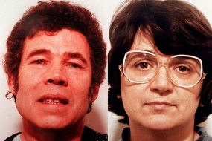Fred and Rose West
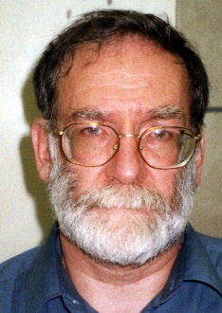Harold Shipman Joanne Dennehey
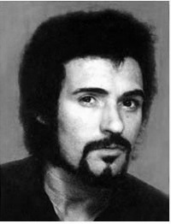Peter Sutcliffe (The Yorkshire ripper)
- Write a fact file which should include the following information:

- Their crimes and victims
- Details of their trial
- Details of their sentence
- Information about their background which might explain their criminal behaviour such as head injuries, mental illness, childhood abuse

Task 2: All about hate crime
- Since the public vote on BREXIT there has been a marked increase in this type of crime. Using the sources below and any others you feel are appropriate answer the questions below:
http://www.independent.co.uk/news/uk/crime/brexit-hate-crime-racism-stats-spike-police-england-wales-eu-referendum-a7126706.html
https://www.victimsupport.org.uk/crime-info/types-crime/hate-crime
http://www.stophateuk.org/
http://www.lgbthatecrime.org.uk/
- What is hate crime?
- Who are the potential victims?
- Find two examples of real victims of hate crime and write a summary of each case
- Find 2 examples of support groups who help victims of hate crime and outline their aims and objectives
- Watch the following documentary on you tube (bbc3 the ugly face of disability – hatecrime)
https://www.youtube.com/watch?v=B03jduD9N5o&safe=active

Task 3: The history of policing
Research and create a timeline of the history of policing in England. Make sure you include:
- When and how policing started in the UK
- Major developments in policing and police investigation
- How the police force is structured now

Task 4: The Jack the Ripper case
Create a case study of the Jack the Ripper case, including what you know about policing at the time and theories about who the killer might be.

Task 5: Caesar Lombroso
It can be argued that Lombroso is the founding father of criminology. Write an approx. 400 word essay about who he was, his background, his theory of the atavistic man and how you can tell who is a criminal by what he looks like.

