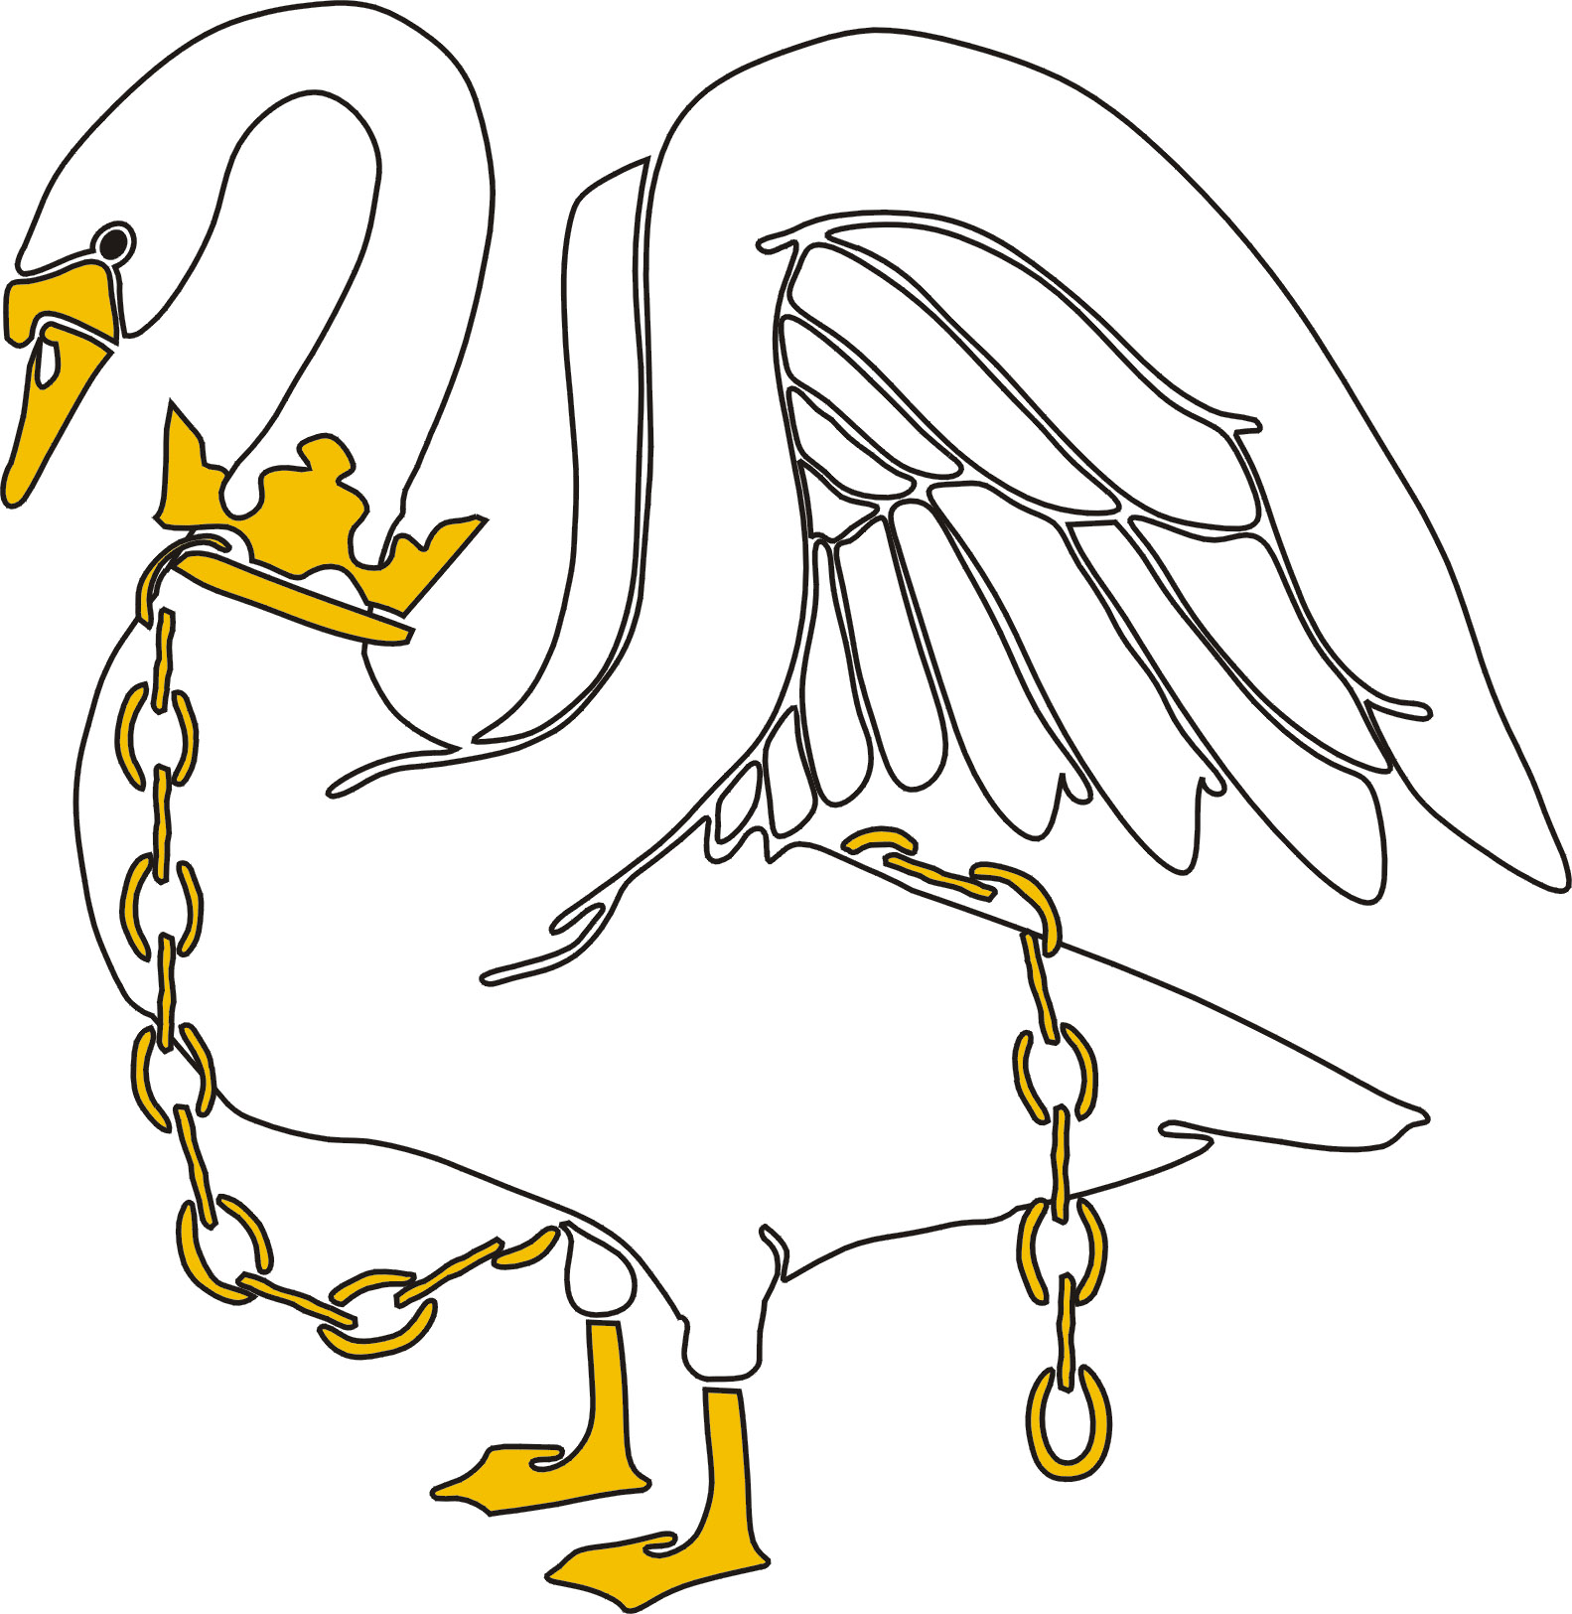
THE BUCKINGHAM SCHOOL

A SPECIALIST SPORTS COLLEGE

London Road
Buckingham
MK18 1AT
Tel: 01280 812206
Fax: 01280 822525

Email: office@buckinghamschool.org
Website: www.buckinghamschool.org
Headteacher: Mr A McGinnes

2 January 2019

Dear Parent/Carer,

I am writing to you to communicate some changes with regards to your child’s reports this year. Our aim in changing the format and frequency of the reports is to support staff, students and parents in understanding where a child is working in comparison to where they should be. It will help all stakeholders identify strengths and areas for development for a student and ensure that support is put in place rapidly for those who require it.

This year, you will be receiving a report at the end of each full-term, i.e., Christmas, Easter and Summer. For all subjects with assessments, these will include:

Minimum Expected Grade (MEG)
This will replace your child’s target grade and will remain the same throughout the Years 7-11. Assessments throughout the years will increasingly become more difficult, to reflect the skills and knowledge required of the students at that point in time. For example, students who should be achieving a minimum of a Grade 5 at GCSE should be getting Grade 5s in their assessments in Years 7-11. As the assessments will get progressively harder, achieving a Grade 5 in Year 8 is not the equivalent of a GCSE Grade 5. It means they are showing the same aptitude as a student that goes on to achieve a GCSE Grade 5 in Year 11. The MEGs are calculated using levels achieved in the KS2 SATS taken in Year 6, combined with national trends of what other students with the same KS2 data, typically achieve at GCSE level.

If your child consistently meets or exceeds their MEG, we want to ensure they continue to be challenged. We would offer them the opportunity to become an Aspirational Learner and give them an Aspirational Grade to work towards.

Forecasted Grade
This will replace your child’s Working At Grade (WAG) and will reflect only the grade your child received on their most recent end of term exam. All students will have end of term exams in all of their assessed subjects (i.e., not core PE or Aspirational Learning) and these have been designed to reflect the style of exam in that subject. They will also examine everything that has been covered so far in their Key Stage; this is to help support the students in preparing for their final GCSE exams which, are all now linear which, means students are only examined at the end of the course. Continually reviewing the content of previous topics helps embed what has previously been learned and what students will need to know for exams at the end of Year 11.

‘Where am I?’ Statement
This gives you an indication of whether your child is working at, above or below their MEG. Where they are working below their MEG, guidance has been provided by their teachers to help your child make progress before the next end of term assessment.

Cont’d…

If your child is ‘working at’ their MEG, it means they are achieving the same as students of a similar ability to them, nationally. They should be really pleased with this. Of course, if they are ‘working above’ their MEG, this puts them above the national average which, is even better. On the contrary, if they are ‘working below’ their MEG, it means they are working at a lower grade to most other students of the same KS2 attainment.

Attitude to Learning Score
This is an indication of how your child has been working in lessons. It has been completed by your child’s teachers using the following criteria:

Score | Description
1 | The student often goes above and beyond minimum expectations in lessons. This may include asking and answering questions out loud, getting involved with class discussions, helping other students, not giving up when struggling, always being positive, presenting work neatly.
2 | The student always meets minimum expectations in lessons. This includes completing all tasks set, following instructions straight away, being polite and kind, having their equipment.
3 | The student does not always meet the minimum expectations in lessons. This may include some low-level disruption, not completing tasks fully, having a negative attitude, not wanting the get involved with group tasks or practical work, forgetting their equipment and course materials.
4 | The student frequently fails to meet minimum expectations. This may include having to be removed from the lesson more than once over the term, regularly refusing the complete tasks, regularly disrupting the lesson.

Extended Learning Score
This is an indication of how your child has been completing their extended learning tasks. It has been completed using the following criteria:

Score | Description
1 | Extended learning regularly exceeds the minimum expectations. This may include completing extension tasks, further reading/research, additional revision questions that are shared with the teacher.
2 | Extended learning is always completed on time and to the student’s best ability.
3 | Extended learning has, on occasion, been late or has not been completed to the student’s best ability.
4 | Extended learning is very often late or not completed. When completed, it does not reflect the student’s best ability.

Term Reflection Sheet
This is designed to be completed at home during a discussion between yourselves and your child as a way of reflecting on the term. This should be completed and handed back in to your child’s Form Tutor who, will help the students to address any issues they are having and then will be handed back out with their next termly report so that you can both reflect on whether any changes have been made, worries quelled and priorities met, etc.

We understand that parents want to support their children at home and hope that the guidance provided for those subjects where your child is working above or below their MEG, allows you to do that and that the reflection sheet prompts some meaningful conversations between you both.

Below is a link to a survey which will allow us to collect feedback on this new format and evaluate the process before the next set of reports at Easter. I would be very grateful if, after reading your child’s report and discussing it with them, you could complete the survey. If you have any specific questions, please include your name in the ‘Specific comments or queries’ section at the end and I will endeavour to respond to you as soon as possible.

https://www.surveymonkey.co.uk/r/GHCB88J
Cont’d…

I thank you once again for your patience with these changes and look forward to working with you to support your child make the most of their potential here at The Buckingham School.

Kind regards.

Yours faithfully,

Miss R Branson
Assistant Headteacher - Data

