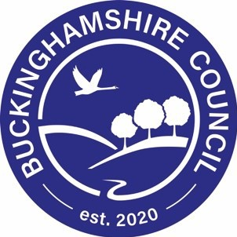
Free School Meals

& Pupil Premium

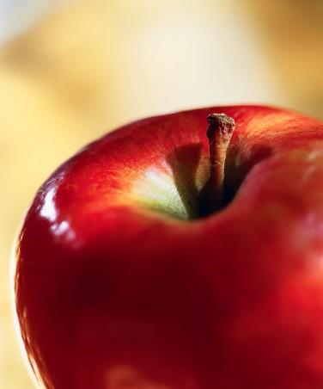
Research shows that better food in schools is improving what children eat during the school day, and there’s evidence of a clear link between what children eat at lunchtime in school, where they eat it and how they focus with their teachers in the afternoon.

All children in reception, year 1 and year 2 in state-funded schools in England are eligible for Universal Infant Free School Meals. This includes infant pupils in maintained infant and primary schools, free schools, academies, special schools and pupil referral units.

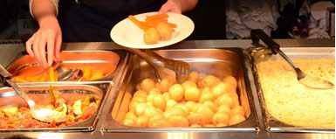
Free School Meals are also available to pupils in years 3 and above whose parents receive certain benefits and register using this application form. Please return this form to your child’s school if you think you qualify for Free School Meals.

Pupil Premium - completing this form could also raise money for your child’s school…
The Pupil Premium is a Government scheme
that provides funding to schools of £955 -
£1,345 per pupil whose parents receive one of the qualifying benefits listed on this application form.

The school can use this money to raise the attainment of disadvantaged pupils and close the gap between them and their peers

Q. How can I apply?
A. Simply complete this application form and return it to your child’s school

Q. Why should I apply?
A. You and your school could benefit from Pupil Premium funding worth £955 - £1345 per pupil. As well as this, if your child is in year 3 or above this form is also used to apply for Free School Meals and could save you hundreds of pounds a year.

Q. My child is in Reception, year 1 or year 2 and automatically receives Universal Infant Free School
Meals, do I still need to complete this form?
A. Yes! Pupil Premium is only paid to a school if the parent registers using this form and is receiving one of the qualifying benefits listed. Even though your child automatically receives free meals at school completing this application form may entitle your school to Pupil Premium funding.

To register for free school meals, including Pupil Premium, please complete this application form and return it to your child’s school as soon as possible to avoid delay.

Buckinghamshire Council 2021/22

FREE SCHOOL MEAL & PUPIL PREMIUM APPLICATION FORM

CHILDREN WHOSE PARENTS/CARERS RECEIVE ONE OF THE FOLLOWING BENEFITS ARE ENTITLED TO FREE SCHOOL MEALS AND WILL GENERATE PUPIL PREMIUM FOR THEIR SCHOOL:

✓ Income Support (IS)
✓ Income-based (not contribution-based) Job
Seeker’s Allowance (IBJSA)
✓ The guaranteed element of the State Pension
Credit.
✓ Income-related employment and support allowance
Children who receive IS or IBJSA in their own right are also
entitled to receive free school meals.

✓ Support under Part VI of the Immigration and Asylum
Act 1999
✓ Universal Credit with an annual net earned income of no more than £7,400
✓ Child Tax Credit (with no Working Tax Credit) with an annual income of no more than £16,190
✓ Where they are entitled to Child Tax Credit and also Working
Tax Credit during the four-week period immediately after their
employment ceases, or after they start to work less than 16 hours per week, their children are entitled to free school meals.

Administration for the provision of free school meals is undertaken by Buckinghamshire Council for those pupils attending an education establishment within Buckinghamshire. This form should be completed and returned to your child’s school.

1. DETAILS OF PARENT/CARER WITH QUALIFYING BENEFIT – COMPLETE IN BLOCK LETTERS

SURNAME/FAMILY NAME as it appears on your benefit letter:

FORENAME: TITLE: DATE OF BIRTH: dd/mm/yyyy

NATIONAL INSURANCE NUMBER OR NATIONAL ASYLUM SEEKER NUMBER
 |  | / |  |  | /

ADDRESS

POST CODE DAYTIME TEL. NO(s)

2. DETAILS OF THE CHILD/CHILDREN

Surname/Family Name Forename Date of Birth Name of School

3. DECLARATION

I declare that the information given on this form is true and complete and I undertake to inform the school if my entitlement to one of the qualifying benefits is terminated. I understand that the results of any free school meal eligibility check may also be used to assess my entitlement to other support/benefits, including free travel to school. The remainder of this declaration does not apply to pupils in Reception, Year1 or Year 2 ‐ I agree that you will use the information I have provided to process my claim for free school meals and will contact other sources as allowed by law to verify my initial, and ongoing, entitlement to free school meals. I understand that I may be liable for any costs incurred in providing free school meals for my child(ren), should I fail to inform the school of the termination of my benefit.
I have read and I understand the above declaration.

SIGNATURE (Parent/Guardian) DATE

s110 of The Education Act 2005 requires that data is only used for its intended purpose, i.e. to determine eligibility for free school meals and that improper use of information is an offence. All LA users are required to sign a declaration to confirm that they will only use data for its intended purpose.

